DELIVRABLES GROUP K

Website Prototype Link:

Kokomo Summer Festival Link : <http://athena.fhict.nl/users/i336041/kokomo/index.html>

Viewed on Google browser resolution.

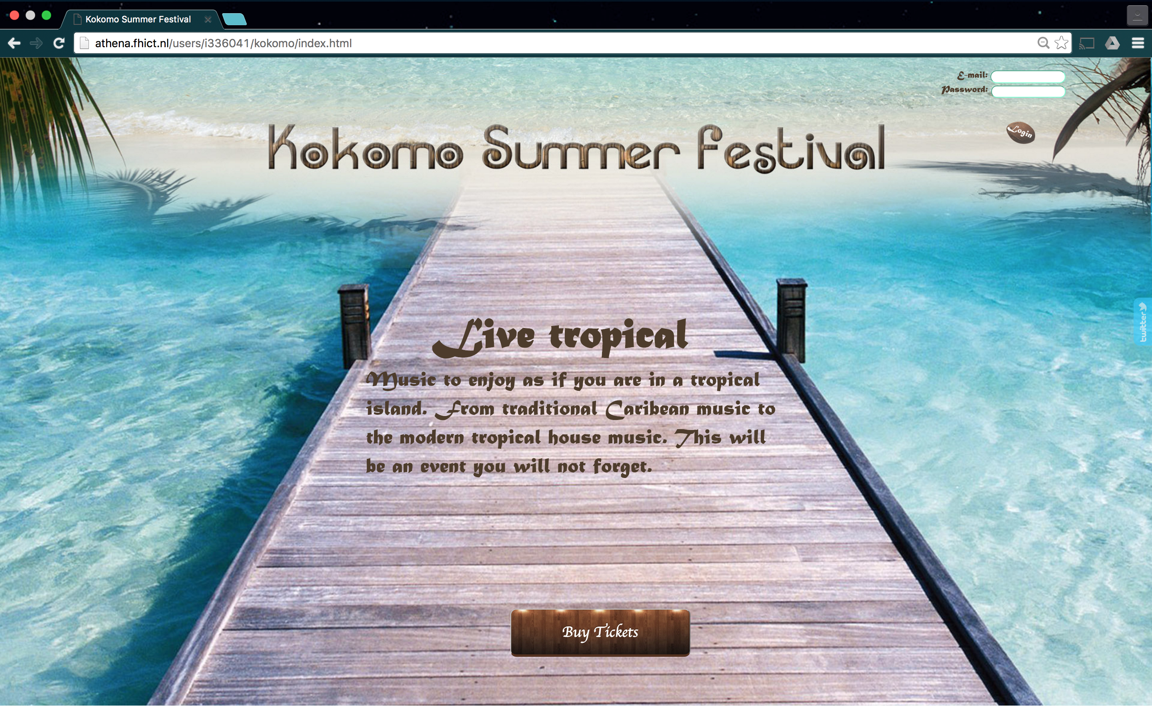

ERD of Database:

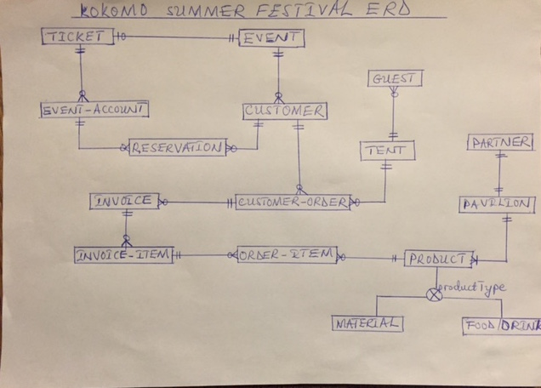

Partial Database implementation in MySQL:

Macintosh HD:Users:simononumajuru:Desktop:Kokomo-phpMyAdmin.pdf